FINDING THE EQUATION OF A STRAIGHT LINE GIVEN A POINT AND THE GRADIENT
Example: Find the equation of a straight line through (3 ; -2) with a gradient of 2.
Solution; Substitute into $y=mx+c$
$$-2=2\left(3\right)+c$$
$-6-2=c$
$-8=c$
Therefore: $y=2x-8$
How to find the gradients Of Parallel Lines?
In coordinate geometry, two lines are parallel if their gradients (m) are equal.

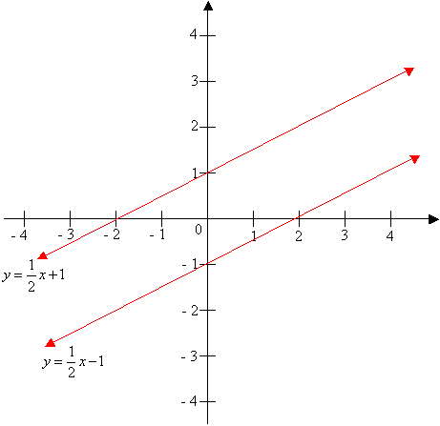
For example: The line y = ½ x - 1 is parallel to the line y = ½ x + 1 because their gradients are both the same ($\frac{1}{2}$)
How to find the equation of a line parallel to a given line and passing through a given point?
Example: Write the equation of a line that is parallel to the line $y=\frac{1}{2}x-1$ and goes through the point (3, 0).

Solution: $m=\frac{1}{2}$ and point (3 ;0)

Hence: $0=\frac{1}{2}\left(3\right)-c$
$\frac{-3}{2}=c$
Therefore: $y=\frac{1}{2}x-\frac{3}{2}$

Exercise 4

- Find the equation of a straight line given gradient -1 and a point ( 4 ; -2).
- Find the equation of a straight parallel to the line $y=-2x-4.$ and passing through the point ( 5 ; 1).

